Edward Dean
Sadly, we are not sure of the precise identity of Edward Dean.
Edward’s service records have gone missing. In the Commonwealth War Graves Commission website there is no E.Dean with any connection to Shevington. There is an Edward Dean commemorated on Wigan’s main war memorial, but his address was in Wigan town centre, and all the other men on our memorial lived locally to Shevington. No reference to Edward Dean has been found by the researchers who have indexed the copies of the Wigan Observer and Wigan Examiner.
Our best guess is that this was 11458, Private Edward Dean, of the 6th battalion, the Loyal North Lancashire Regiment, who died in Mesopotamia on 9th April, 1916.
In 1911 Edward’s address was 196, City Road, Kitt Green. Really this is on the wrong side of the Douglas, but he might have moved or have worked in a Shevington colliery.
Edward may well have fought at Gallipoli. His body was never recovered and he left a wife and two children. His name is recorded at the Basra Memorial in Iraq.
The Basra Memorial commemorates more than 40,500 members of the Commonwealth forces who died in the operations in Mesopotamia from the autumn of 1914 to the end of August 1921 and whose graves are not known. The memorial was designed by Edward Warren and unveiled by Sir Gilbert Clayton on the 27th March 1929.
Edward’s family
James Dean married Ellen Shepherd in June 1882.
In 1891 the family were living at 31, City Road, and there were four children, of whom Edward was the eldest (8 years old), together with Samuel Shepherd, presumably a son from Ellen earlier partnership.
Ten years later, there were six children; our Edward was 18 years old and described a coalminer.
Our Edward married Jerusha Fairhurst on 4th February, 1905. (Jerusha was the wife of King Uzziah of Judah.)
By 1911, they had a house of their own, 196 City Road, two children, and a boarder, Thomas Fairhurst, presumably Jerusha’s brother. Edward was described as a contractor’s labourer; Thomas was a miner.
Edward’s work
Edward was a miner. If he lived in City Road he could have walked across Wigan Lower Road to the Lower Ground Pits.
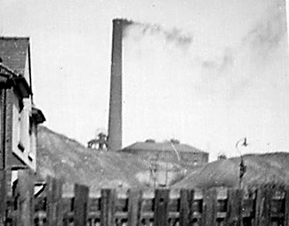
Giants Hall Pit

Edward was a haulier – he pushed or pulled the pit tubs from the coal face to the winding shaft.
What happened to Edward?
If Edward died in Mesopotamia, to which the 6th battalion had been sent, it is most likely that he died either as a result of military action or as a consequence of disease when the British army were besieged in the city of Kut.
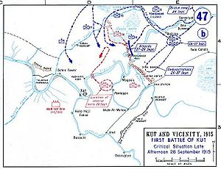
The British Empire forces arrived at Kut around 3rd December 1915. They had suffered significant losses and were down to around 11,000 soldiers (plus cavalry). General Townshend chose to stay and hold the position at Kut instead of continuing the march downriver towards Basra. Kut offered a good defensive position because it was contained within a long loop of the river. The problem was how to get supplies, since Kut was a long way from Basra. Several attempts were made to lift the siege and get supplies to the troops, but all failed.
The British Empire’s forces numbered about 30,000 soldiers, roughly equal to the Ottomans. The battle began on 5th April and the British soon captured Fallahiyeh, but with heavy losses, Bait Asia was taken on 17th April. The final effort was against Sannaiyat on 22nd April. The Allies were unable to take Sannaiyat and suffered some 1,200 casualties in the process.
General Townshend arranged a ceasefire on the 26th April and, after failed negotiations, he simply surrendered on 29th April 1916 after a siege of 147 days. Around 13,000 Allied soldiers survived to be made prisoners. By then, Edward Dean had died.

